Part II: Padlet
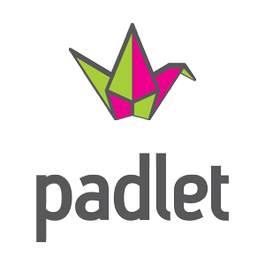

- What is Padlet?
  - Online bulletin board
  - Easy way to collaborate
  - Works like an online piece of paper
- How can you use it in your classroom?
  - Exit Ticket for learning
  - Posing a homework question for students to answer (give them link)
  - Starter for the day Question
  - As a KWL chart
  - Group research
  - Create a page to display student work (digital work) and link it to your teacher webpage
  - Ways we discussed in class:
    - ___________________________________
    - ___________________________________
    - ___________________________________
    - ___________________________________
    - ___________________________________
    - ___________________________________
- So, how do you use Padlet?
  - www.padlet.com
  - Create an account. All you need is your email address and a password.
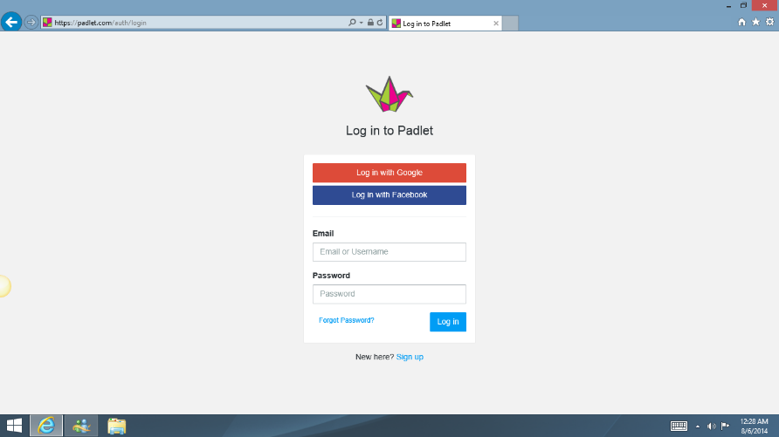
- Once you create your account, the home page is pretty easy to navigate. It will open in “Dashboard.”
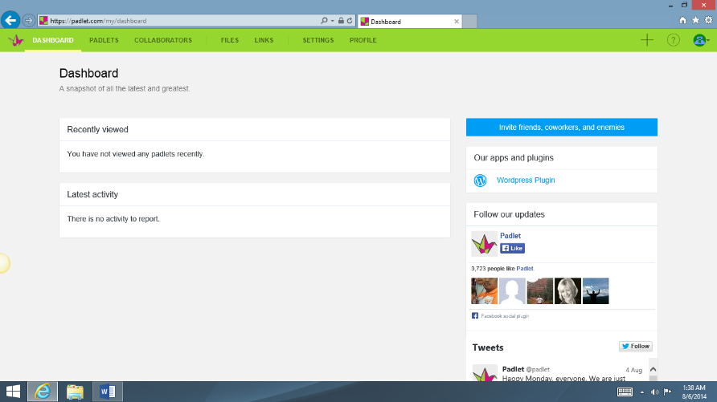
- Click on the “+” sign to make a “wall.” You can do this in any tab.
- Once you have created a “wall,” you will see any other walls that you have created in a list in your Padlets tab.
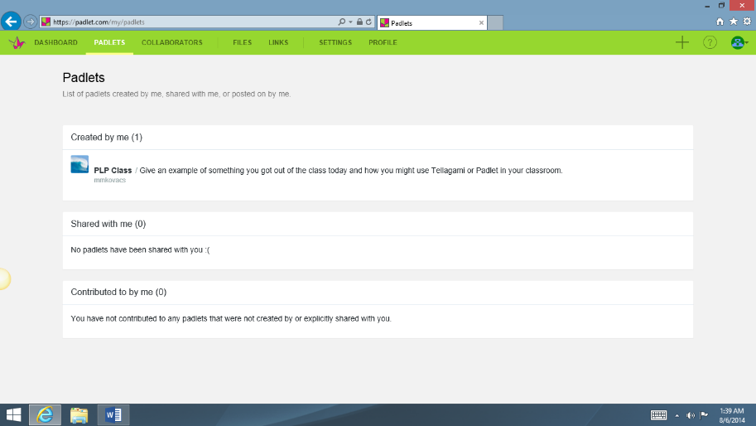
- To customize your wall page, there is a dark grey/black tbar on the right hand side of the page. Each “icon” will allow you to do something different. First, click on the “Modify this wall” icon. (It looks like a little gear tool.)
- This will allow you to customize your wall page. Also notice the wall has an official address. You will need that link for your students to access the wall.
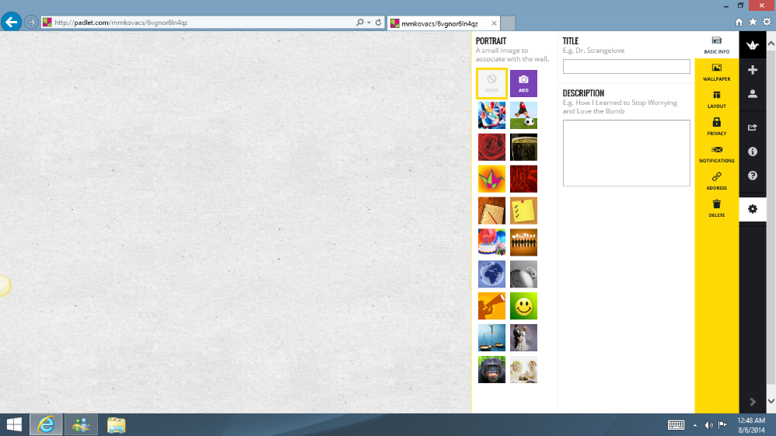
- That icon opens to the screen above. You are in the “Basic Info” screen. This is where you can give your wall a little picture (under PORTRAIT) with the TITLE you name your wall. I would suggest making your DESCRIPTION your assignment directions.
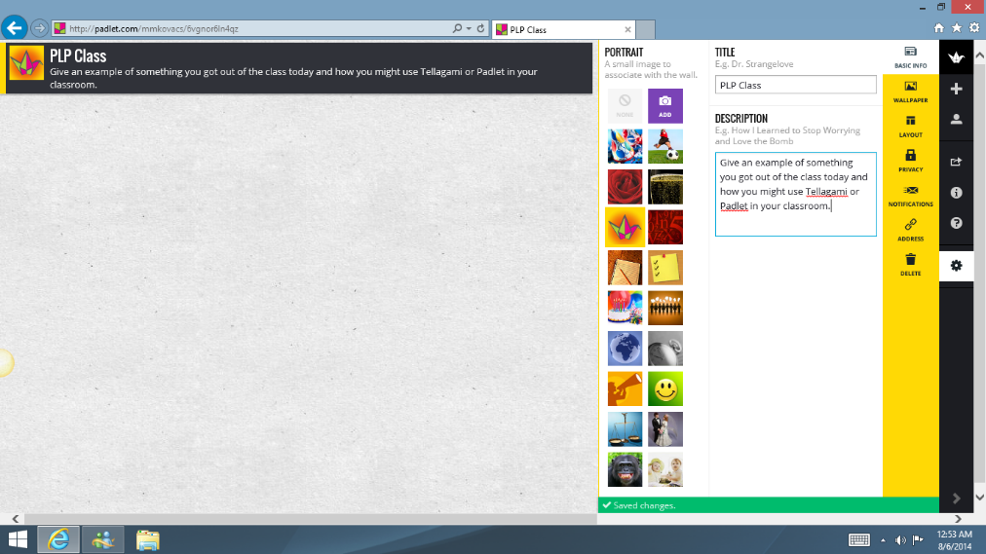
- All the “tools” you will need are highlighted in the gold bar on the right hand side of the screen to make the Padlet wall.
- You can customize the background as well by clicking on the WALLPAPER icon. On our page, I made it a wave, which is in the Padlet selections. You can also upload a picture from your own photo library.

- Next, determine the type of LAYOUT your wish to have on your wall by clicking on the LAYOUT icon in the gold bar.
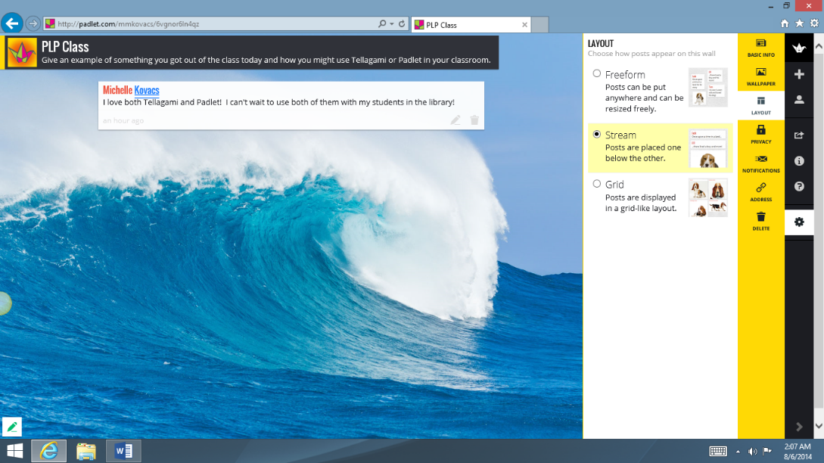
- You can choose from FREEFORM, STREAM OR GRID. Freeform, is just that – all over the page when you or the student go to post. The posts can be moved by clicking and dragging once completed. To make your wall easier to read, I would suggest the STREAM or GRID option. I have made our page STREAMED. It will put all of the posts one under the other.
- Another suggestion – to show students how their post will look in this format, post a comment as I did on our wall. (Screenshot above.) Then each post after will just compile under it.
- To make a post, simply DOUBLE CLICK on the wall. It will make a little caption box. You will want to remind your students to put their name first, as it makes it in BOLD. Their comment/answer will be under it where it says “write something.
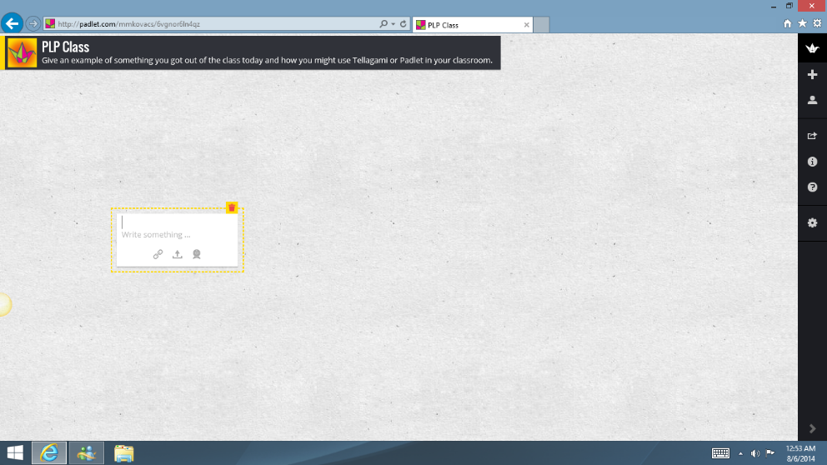
- PRIVACY – the program automatically defaults to HIDDEN LINK, where it cannot be “googled” or found on Padlet. You as the wall creator, must share the link (the address line) with your students for them to be able to write on the wall. As a suggestion, I would leave the drop down menu to CAN WRITE. This allows your students to post, but they can’t make changes to your question/assignment, wallpaper or others’ posts. They will only be able to make changes to their post.
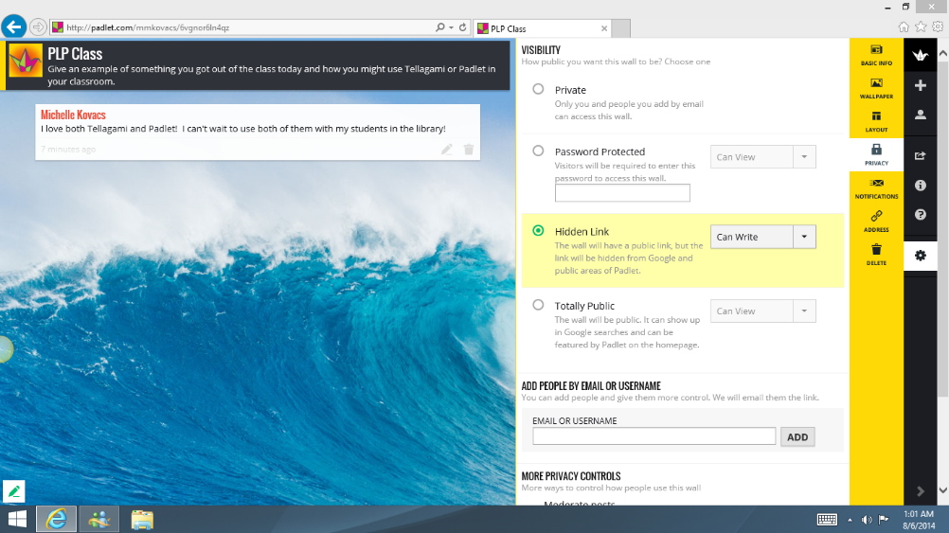
- There are other PRIVACY options, especially if you need to MODERATE your comments prior to your students actual live posting.
- NOTIFICATIONS – the program will send you an email once a day if posts are made to your wall. Unless you want another email to delete, I’d leave this option off.
- Next is the ADDRESS icon. You will want to determine how you want the address to be. You can leave it with the default one (as I have), give it a special name or if you happen to have your own domain, you can add it to that. My suggestion is option one (leave it default) and post the link to your teacher webpage. This way, students don’t have to write down the link to access it. It will eliminate mistakes to the address and them not finding the wall. I posted our wall link to my blog page. www.librarianintheforest.weebly.com
- That’s it for the gold bar of icons!
- You can also SHARE your wall in a variety of ways… just use the dark grey/black bar SHARE/EXPORT icon. This would allow you to embed the link to your teacher webpage to show off your student’s work, and the site automatically creates a QR code to access that particular wall, so you could copy and past the QR code into an email to share it or paste it to your webpage for access to others. Be aware, this would allow people to post to the actual wall, unless you change the PRIVACY settings. (You could change the PRIVACY settings once all your students have posted, making the wall view only through those share options.)
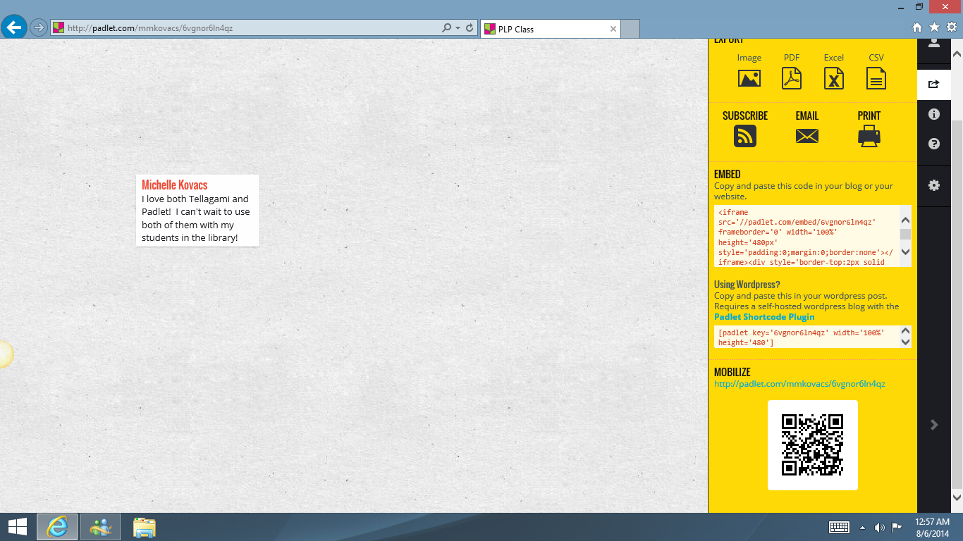

- Other Information:
  - There is no limit to the number of people that can post at the same time on the wall.
  - There is a great HELP icon in the dark grey/black bar if you are not sure how to do something or are looking for more advanced options. It is a little ? icon.
